

BY

**DEPARTMENT OF COMPUTER**

**MOTHER TERESA INSTITUTE OF**

AUTONOMOUS

**PROJECT REPORT**

**A Major Project Report Submitted in Partial**

**Fulfillment of the Requirements Award of Degree of**

**BACHELOR OF TECHNOLOGY**

**UNDER THE ESTEEMED GUIDANCE OF**

**Mr. M. VENKATESWARAO,**

M. Tech

(

**21C61A0537**

)

**In**

**COMPUTER SCIE**

**NCE & ENGINEERING**

**SCIENCE AND ENGINEERING**

On

Assistant professor

Accredited By NAAC with ‘A+’ Grade

Approved by AICTE, Govt. of Telangana & SBTET, Affiliated to JNTUH, Hyderabad.

Recognition under section 2(f) & 12(B) OF THE UGC Act,1956

Sanketika Nagar, Sathupally-507303, Khammam (Dist), Telangana State.

**“PETROL PRICE FORECASTING USING AUTO KERAS”**

**SCIENCE AND TECHNOLOGY**

**N ASHMITHA**

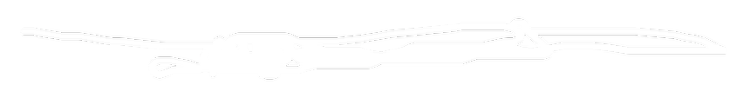

**Guide**

**Internal Examiner**

**Date:**

**External Examiner**

**Date:**

**Head of The Department**

**MOTHER TERESA INSTITUTE OF SCIENCE AND TECHNOLOGY**

**AUTONOMOUS**

This is to certify that the Project entitled **“PETROL PRICE FORECASTING USING AUTO KERAS”** is a bonafied work done by **N.ASHMITHA (21C61A0537)** . In partial fulfillment of the requirements for the award of the Degree of Bachelor of Technology in **COMPUTER SCIENCE & ENGINEERING** from Jawaharlal Nehru Technological University Hyderabad During the Academic Year 2024- 2025.

Accredited By NAAC with

**‘A+’**

Grade

Approved by AICTE, Govt. of Telangana & SBTET, Affiliated to JNTUH, Hyderabad.

Recognition under section 2(f) & 12(B) OF THE UGC Act,1956

Sanketika Nagar, Sathupally-507303, Khammam (Dist), Telangana State.

**Mr. M.VENKATESWARAO**

**Mr. P. MARESWARA RAO**

**CERTIFICATE**

**M. Tech.,**

**M. Tech., (Ph.D)**



I also thank the entire faculty members and fellow classmates who directly or

indirectly helped us.

I am grateful to numerous individuals who contributed to the preparation of our

Project Report.

I wish to express our sincere and heartful gratitude to our Technical seminar Guide

**Mr. M.VENKATESWARAO**

**M.Tech**

**Assistant Professor**

,

**COMPUTER SCIENCE &**

**ENGINEERING**

, who encouraged us to take up a project in sync with global

trends,with a programmatic approach and constant encouragement and cooperation

during the project report.

I thank and deep sense of gratitude to

**Mr.P.MARESWARA RAO M.Tech,(Ph.D).**

Assistant

Professor, Head of

Department,

**COMPUTER SCIENCE & ENGINEERING**

for their constant encouragement and cooperation during the

project report.

I would like to thank and express our gratitude to

**Dr. SK. JAKEER HUSSAIN,**

**M.Tech, Ph.D,**

Dean of Engineering, Mother Teresa Institute of Science &

Technology for the support and encouragement during the completion of the project

report.

**ACKNOWLEDGEMENT**

I express my gratitude and utmost regards to

**Dr. C. HARI KRISHNA,M.E,Ph.D,**

**MIEEE, MISTE,**

Principal, Mother Teresa Institute of Science & Technology for their

constant support, encouragement and providing necessary permissions during the project

completion of the project.



**DECLARATION**

We hereby certify that the Project Report entitled **“PETROL PRICE FORECASTING USING AUTO KERAS”** under the guidance of **Mr. M. VENKATESWARAO**, **M.Tech** is submitted in partial fulfillment of the requirements for the Award of the Degree in Bachelor of Technology in **COMPUTER SCIENCE & ENGINEERING**. This is a record of bonafied work carried out by us and the results embodied in this Project Report have not been submitted to any other University or Institute for the Award of any other Degree.

,

**DATE:**

Department of Computer Science & Engineering (CSE)

Mother Teresa Institute of Science & Technology, Sathupally.

**N.ASHMITHA**

BY

**(21C61A0537)**



**INSTITUTE VISION**

**INSTITUTE MISSION**

**DEPARTMENT VISION**

**DEPARTMENT MISSION**

To be a state-of-the-art center for learning with a social commitment

transforming the youth into Dynamic Professionals.

**DM1:**

Provide a cutting-edge curriculum that integrates theoretical knowledge

with practical skills, preparing students for the evolving tech landscape.

**DM2:**

Establish strong partnerships with industry leaders to offer students

real-world experience through internships, projects, and mentorship

programs.

**DM3:**

Promote ethical standards and social responsibility in the development

and application of Technology.

To be recognized as a contributor to

**Computer Science & Engineering**

proficiency and

enable entrepreneurship, innovation, and values.

**IM1**

Foster unmatched excellence in professional education.

:

**IM2:**

Provide a quality eco-system to inspire learning aligned to needs.

**IM3:**

Inculcate ethical and moral values to groom good citizens.

**IM4:**

Involve in activities with team spirit and collaborations towards nation-building.



**PROGRAMME EDUCATIONAL OBJECTIVES (PEOs)**

**PSO1**

:

An ability to specify, analyze & design efficient computer applications that

meet requirements and limitations.

**PSO2**

:

An ability to implement an algorithm for a secure and reliable

data communication system.

**PSO3**

:

Able to excel in competitive exams Zest for higher studies with technical

competency

**PROGRAMME EDUCATIONAL OBJECTIVES (PEOs)**

**PEO1:**

Develop innovative computing products and complex solution

techniques by utilizing strong technical proficiency and critical thinking.

**PEO2:**

Demonstrate professionalism, ethical attitude, teamwork, and leadership

skills with lifelong learning.

**PEO3:**

Exhibit effective communication skills and social concerns to meet the

challenges of software industries.

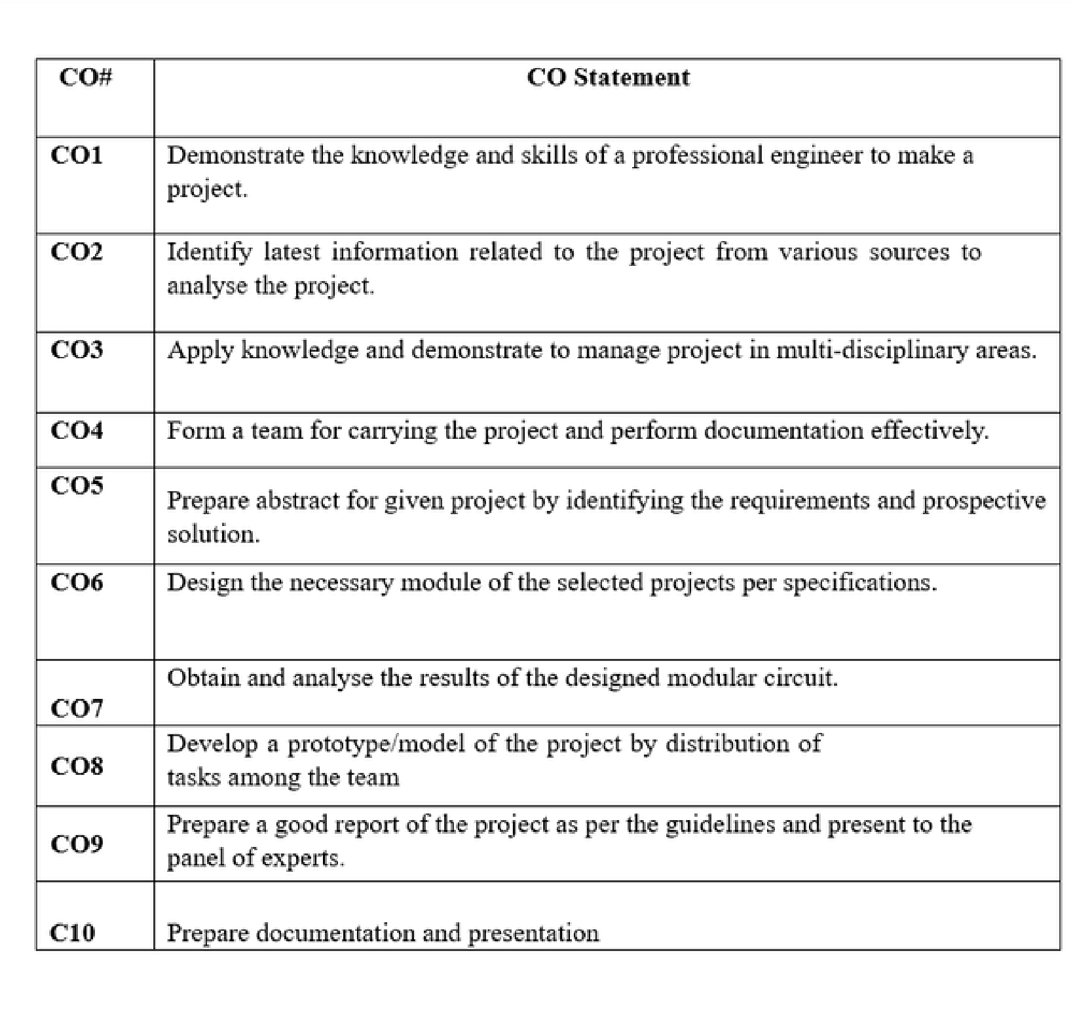

MOTHER TERESA INSTITUTE OF SCIENCE AND TECHNOLOGY

AUTONOMOUS

Phone:

Off:

9121901251

Web : www.mist.edu.in E

Mail: info@mist.edu.in

SANKETIKA NAGAR, KOTHURU (V), SATHUPALLY – 507303, KHAMMAM Dist., TELANGANA

**Course: Project Stage II**

**Class: IV B. Tech II Sem**

**AY: 2024-2025**

**Mr. P. MARESWARA RAO**

, M.Tech, (Ph.D), MISTE

Associate Professor

Department of

**COMPUTER SCIENCE & ENGINEERING**



**Department of Computer Science and Engineering**

**Program Outcomes (POS)**

**PO1: Engineering knowledge:**

Apply the knowledge of mathematics, science, engineering fundamentals, and an

engineering specialization to the solution of complex engineering problems.

**PO2: Problem analysis:**

Identify, formulate, review research literature and analyze complex engineering

problems reaching substantiated conclusions using first principles of

mathematics, natural sciences, and engineering sciences.

**PO3:**

**Design/development of solutions:**

Design solutions for complex engineering problems and design system

components or processes that meet the specified needs with appropriate

consideration for the public health and safety, and the cultural, societal, and

environmental considerations.

**PO4: Conduct investigations of complex problems:**

Use research-based knowledge and research methods including design of

experiments, analysis and interpretation of data, and synthesis of the

information to provide valid conclusions.

**PO5: Modern tool usage:**

Create, select, and apply appropriate techniques, resources, and modern

engineering and IT tools including prediction and modeling to complex

engineering activities with an understanding of the limitations

**PO6:**

**The engineer and society:**

Apply reasoning obtained by the contextual knowledge to assess societal, health,

safety, legal and cultural issues and the consequent responsibilities relevant to the

professional engineering practice.



**Department of Computer Science and Engineering**

**Program Outcomes (POS)**

**PO7:**

**Environment and sustainability:**

Understand the impact of the professional engineering solutions in societal and

environmental contexts, and demonstrate the knowledge of, and need for

sustainable development

**PO8: Ethics:**

Apply ethical principles and commit to professional ethics and responsibilities

and norms of the engineering practice.

**PO9: Individual and team work:**

Function effectively as an individual and as a member or leader in diverse

teams, and in multidisciplinary settings.

**PO10: Communication:**

Communicate effectively on complex engineering activities with the engineering

community and with society at large, such as, being able to comprehend and

write effective reports and design documentation, make effective presentations,

and give and receive clear instructions.

**PO11: Project management and finance:**

Demonstrate knowledge and understanding of the engineering and

management principles and apply these to one’s own work, as a member and

leader in a team, to manage projects and in multidisciplinary environments.

**PO12: Life-long learning:**

Recognize the need for, and have the preparation and ability to engage in

independent and life-long learning in the broadest context of technological

change.



Python

The major requirement for implementing this project is

Python Programming Language along with its Libraries

PREDICTION OF FOREST FIRES USING

MACHINE LEARNING

Able to prepare a thesis and presented to a panel of Experts

Train the system to predict the forest fire occurence

PO7

PO8

PO1

PO2

PO3

PO4

3

2

Project Work

Project Work

Project Seminar

3

**Name of Course from**

**which Principles are**

**applied in this project**

1

3

3

1

1

3

3

3

3

**Description of the application, page number in the report**

3

3

**Project – PO Mapping**

**PETROL PRICE FORECASTING USING AUTO KERAS**

Mr. M. VENKATESWARAO., M. Tech

N ASHMITHA

2

**Attained PO**

MOTHER TERESA INSTITUTE OF SCIENCE AND TECHNOLOGY

AUTONOMOUS

Phone:

Off:

9121901251

Web : www.mist.edu.in E

Mail: info@mist.edu.in

SANKETIKA NAGAR, KOTHURU (V), SATHUPALLY – 507303, KHAMMAM Dist., TELANGANA

**Project Title**

**Guide(s):**

**Student Name:**

**Student Roll No:**

21C61A0537

**Academic Year:**

2024-25

**PO**

**Mapping**

PO1

PO2

PO3

PO4

PO5

PO6

PO7

PO8

PO9

PO10

PO11

PO12

PSO1

PSO2

PSO3

**Guide/Supervisor Signature**



PROJECT DONE BY:

PETROL PRICE FORECASTING USING AUTO KERAS

BATCH-10

COURSE

:

BACHELOR OF TECHNOLOGY

BRANCH:

COMPUTER SCIENCE AND ENGINEERING

N.ASHMITHA

(21C61A0537)

ABSTRACT

Forest fires are a growing global concern, causing significant environmental and societal damage due to factors like global warming, lightning, and human negligence. Early and accurate detection is crucial for effective mitigation. Current forest fire prediction methods often face challenges with computational time and accuracy, especially when dealing with large datasets. Many existing machine learning techniques, while useful, exhibit varying levels of performance, with Support Vector Machines (SVM) showing promise for their accuracy in identifying smaller fires that can escalate into larger events. However, traditional SVM implementations can be computationally intensive and memory-demanding for large datasets, producing numerous support vectors that impact efficiency.

This project addresses these limitations by proposing a robust and efficient forest fire prediction system utilizing a Parallel Support Vector Machine (PSVM) algorithm. The primary objective is to develop a machine learning model that accurately predicts forest fires using meteorological data, leverages PSVM for enhanced speed and accuracy, and provides timely alerts to authorities. The methodology involves collecting comprehensive meteorological data from the Indian Meteorological Department (IMD), including temperature, wind, rainfall, and relative humidity. From these basic parameters, crucial forest fire weather indices (FFMC, DMC, DC, ISI, BUI, FWI) are calculated, which are vital for determining wildfire intensity.

The system architecture involves feeding the IMD dataset into a Parallel SVM model. The

data is pre-processed, calculating dependent attributes based on independent attributes, and then split into training and testing sets. To overcome the computational challenges of large datasets, the project employs Apache Spark and PySpark for big data processing and parallel computing, significantly reducing computation time and improving accuracy by efficiently managing support vectors. The PSVM approach involves dividing large datasets into smaller subsets, processing them in parallel with multiple SVMs, and iteratively refining support vectors to achieve a global optimum with maximum margin from the hyperplane.

The front-end user interface is developed using the Django web framework, allowing users to upload test data for forest fire prediction and receive alert messages. Upon prediction of a fire (Fire = 1), an alert is sent to relevant departments, such as the Ministry of Environment, Forest, and Climate Change (MOEFCC), facilitating proactive fire management. The results demonstrate that the Parallel SVM model achieves higher accuracy (1.0) and recall (1.0) compared to a linear SVM (accuracy 0.94, recall 0.93), with an execution time of 0.051 seconds, validating its enhanced performance and efficiency in predicting forest fires. This system offers a reliable and efficient tool for forest fire prevention and management, enabling timely interventions and reducing destructive impacts.

# PREDICTION OF FOREST FIRES USING MACHINE LEARNING



TABLE OF CONTENTS

S.No

Title

Page No.

1

2

3

4

Certificate

Declaration

Abstract

Acknowledgement

Table of contents

List of Figures

List of Tables

List of Abbreviations

INTRODUCTION

1.1

Relevance of the Project

Problem Statement

1.2

1.3

Objectives

1.4

Scope of Project

1.5

Methodology

LITERATURE SURVEY

SYSTEM REQUIREMENTS SPECIFICATION

3.1

Functional Requirements

3.2

Non-Functional Requirements

Hardware Requirements

3.3

3.4

Software Requirements

SYSTEM ANALYSIS AND DESIGN

4.1

System Architecture

4.2

Implementation Framework

4.3

Dataset

4.4

Flowchart

ii

iii

iv

v

vi

viii

ix

x

1

3

3

4

4

4

6

16

16

16

17

17

18

18

19

20

25

# PREDICTION OF FOREST FIRES USING MACHINE LEARNING



5

6

7

8

9

IMPLEMENTATION

5.1

Support Vector Machine

5.2

Parallel Support Vector Machine

Front-end and Back-end implementation details

5.3

RESULTS AND DISCUSSION

TESTING

Performance of the model

7.1

Comparison between Linear SVM and Parallel SVM

7.2

CONCLUSION AND FUTURE SCOPE

Conclusion

8.1

8.2

Future Scope

REFERENCES

APPENDIX- A

26

26

28

29

39

44

44

46

47

47

48

49

51



LIST OF FIGURES

S.No.

Fig 1.1

Title

Data Flow Diagram

Page No

Fig 2.1

Fig 4.1

Fig 4.2

Fig 4.3

Fig 4.4

Fig 5.1

Fig 5.2

Fig 5.3

Fig 5.4

Fig 5.5

Fig 6.1(a)

Fig 6.1(b)

Fig 6.2

Fig 6.3

Fig 6.4(a)

and (b)

Fig 6.5

Forest Fire Prediction Report sent as Alert

Sample Dataset

System Architecture

Django implementation framework

Structure of FWI System

Process Outline

Support Vector Machine

Hyperplanes in 2D and 3D

Parallel Support Vector Machine

Command Prompt

User Interface

Linear SVM Results

Parallel SVM Results

Predicted Fire Days

Fire Intensity vs. Month

Validation Predictions with Actual Fire Possibilities

43

.

1

6

18

20

24

25

26

27

28

29

36

39

40

41

41

42



LIST OF TABLES

S.No.

Table 7.1

Title

Performances in terms of accuracy, precision and Kappa

Page No.

Table 2.2

Table 7.1

Comparison of different Methodology with pros and cons

Comparison between Linear SVM and Parallel SVM

9

13

40



LIST OF ABBREVIATIONS

Abbreviations

Full Forms

SVM

FFMC

DMC

DC

FWI

PCA

KNN

MPI

PSO

CNN

MPNN

PNN

Support Vector Machine

Fine Fuel Moisture Code

Duff Moisture Code

Drought Code

Forest Fire Weather Index

Principal Computation Analysis

K- Nearest Neighbors

Message Passing Interface

Particle swarm optimization

Cascade correlation network

Multilayer perceptron neural network

Polynomial neural networks

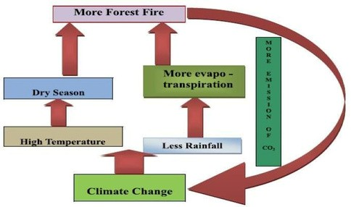

CHAPTER 1

INTRODUCTION

Fig 1.1: Data Flow Diagram

Forest fires have become one of the most frequently occurring disasters in recent times

which

cause

destruction

to

large

acres

of

forests.

One

of

the

main

reasons

behind

the

occurrence of forest fires is global warming which is one of the major causes of increase in

average temperature of the earth. The other reasons are due to lightning, thunderstorms,

and human negligence. Forest fires can lead to deforestation which has a lot of negative

impact on human society. It is reported that for the last decade, each year, more than

100,000

in all countries. Early detection of forest fires is very important in fighting against

fires. Spread features of forest fires show that, in order to put out a fire without causing

any permanent damage in the forest, the fire fighter center should be aware of the threat at

most 6 min after the start of the fire.

Forest fires prediction combines weather factors, terrain, and dryness of flammable

items, types of flammable items, and ignition sources to analyze and predict the combustion

risks of flammable items in the forest. There are many techniques that the authorities use to

detect forest fires, satellite detection is widespread among worldwide authorities. Few forest

authorities use human observers as detectors and reporters of forest fires.



Fig 1.1 displays a data flow map for forest fires and climate change worldwide. In this

article, we compare the various methods used in related research. In each of the methods

used, there are different advantages and disadvantages. Data mining and machine-learning

techniques may provide an effective mitigation strategy, where forest-related data can be

used to predict forest fires. Owing to changes in earth's orbital parameters, solar intensity,

and

atmospheric

composition,

the

environment

and

associated

weather

are

not

continuous.

Our atmosphere has warmed up in recent years due to changes in human behavior in

the air in radioactively active gases (carbon dioxide, methane, etc.). Such warming is likely to

have a profound impact on fire activity in the forest zone.

Based on weather altering factors, we restrict our research to forest fires. From recently

on, it appears that they greatly impact the frequency of wildfires. By analyzing these causes,

we are developing a stronger and more efficient way of predicting forest fires. The IMD (Indian

Meteorological Department) dataset is split into training data and test data. The training data

were used in the supervised learning model. This model will now forecast forest fires on the

basis of the input test results. For testing various test data to forecast the occurrence of forest

fires a user interface is created.

There are many Machine Learning models used to predict forest fires and alerts the

forest department. Some of the techniques used to detect these fires are logistic regression,

random forest, K-Nearest Neighbor, Support Vector Machine, Artificial Neural Networks,

Gradient Boosting, Bagging, etc. There are various advantages and disadvantages in each of

the methods used. From our literature survey we concluded that SVM is the most suitable

technique which can be used. SVM is not only a good classification algorithm but also a good

regression algorithm. SVM gives accurate results in case of small fires which eventually lead

to large fires. Therefore SVM is the most efficient method for forest fire prediction.



To predict the occurrence of forest fire using Parallel Support vector machine algorithm to

provide accurate and faster results by calculating forest weather index for basic weather

parameters which is an important factor to determine the intensity of the wildfire.

SVM for large datasets produce a large number of support vectors which increase the

computation

time

and

storage

requirements.

Therefore

SVM

is

implemented

using

parallel computing, in our case parallel SVM. Splitting the dataset into sub datasets and

using subSVMs to evaluate each dataset to filter the support vectors from non-support

vectors so that the last global sub-SVM will have only one set of support vector which is

easy to classify and because we use many sub-SVMs simultaneously, computation speed

is increased and accuracy of prediction also is increased.

Data

mining

and

machine

learning

techniques

can

provide

an

efficient

prevention

approach where data associated with forests can be used for predicting the occurrence of

forest fires. Fire activity is strongly influenced by four factors – weather/climate, fuels,

ignition agents and human activities. Climate and the associated weather are not constant

due

to

changes

in

the

earth’s

orbital

parameters,

solar

output

and

atmospheric

composition.

Recently, our climate has been warming as a result of increases of radioactively active

gases (carbon dioxide, methane etc) in the atmosphere caused by human activities. Such

warming is likely to have a profound impact on fire activity in the forest zone.

We are limiting our study to predict forest fires based on weather altering factors. As

of recent, they seem to be affecting the occurrence of wildfires greatly; we aim to devise a more

accurate and faster method to predict forest fires by studying these factors.

1.2

Problem Statement

1.1

Relevance of the Project



●

●

●

1.3

1.4

Objectives

1.5

Methodology

Parallel Computing

Scope of the Project

Traditional computation instructions in a queue pass through the processor and

processor does the processing and get the processed data

The problem with this type of approach is we can only make the processor faster to

limit i.e., there is a frequency limit, heat.

To increase the speed of processing we use two processors which divide the

instructions among them.

The goal of this project is to predict forest fires using machine learning algorithms. This

project uses SVM to provide better accuracy. It also uses parallel computing for high

speed computation.

The dataset provided by IMD (Indian Meteorological Department) will be divided into

training data and test data. The training data is fed into the model for supervised learning. This

model should now predict forest fires based on the test data given as input. A user interface is

developed for testing different test data to predict the occurrence of forest fires.

●

To create a machine learning model

●

It is used to predict forest fires

●

It uses meteorological data

●

It uses support vector machine (SVM) technique for better accuracy for small forest fires

●

It uses parallel computing (parallel SVM) for high speed computation

●

To create a user interface for predicting forest fires and display an alert message to

authorities like the Ministry of Environment, Forest, Climate Change (MOEFCC).



●

●

●

●

●

●

●

●

●

●

●

●

Two processors running in parallel dividing the instructions among them (workload

distributed)

It is a supervised learning algorithm for classifying data

Uses hyperplane to separate data to segments where each segment has one kind of data

Classification based on features of the data

SVM is used for regressions as well

SVM kernel function for classifying non linear data

Plot the data as nodes on n dimensional space and draw hyperplane

Closest points to the hyperplane are called support vectors and have max distance

from the hyperplane

SVM is taken as a most efficient classification and regression model.

Classical SVM model is difficult to analyze large scale practical problems.

Parallel SVM can improve the computation speed greatly.

In our project we plan on handling large datasets using Apache Spark and use parallel

SVM for more accuracy with better computation speed.

Parallel SVM

Support Vector Machine

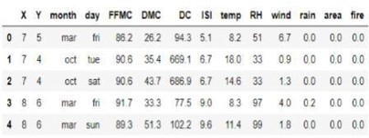

CHAPTER 2

LITERATURE SURVEY

Forest fires are managed by weather data collection or by the processing of satellite

forest photos. Rapid detection can help us control damage effectively. Earlier work has

shown that forest fires can be caused for many causes and it is therefore very important

to accurately make predictions. Many machine learning techniques were applied and

compared in order to construct a prediction model. The SVM model provides reliable

forecasts for the use of the environment in small forest fires, which inevitably lead to

larger fires. When forecasting forest fires using weather information, the forest weather

predictor along with basic weather parameters must be taken into account. We show

that

through

parallel

computation

with

vector

support

engines

the

accuracy

of

this

predictive model can be enhanced.

Fig 2.1: Sample Dataset

To analyse the data in datasets and how each feature affects the forest fires and some of

the techniques used for solving regression and classification problems used in this study

are discussed. The dataset includes: X and Y axes special park coordinates, Fine Fuel

Moisture Code (FFMC), Duff Moisture Code (DMC), Drought Code (DC) and Initial

Spread

Index

ISI).The

(

other

characteristics

used

are

temperature,

relative

humidity,

wind speed, rain outside and the burnt forest region. All these features were collected

from January to December on all days for a whole year.

1.1

Supervised and Ensemble Machine learning algorithm

Fig 2.1[1] represents a sample (first 10 rows) of the UCI forest fire dataset. In this paper, there are two graphs plotted, variance of feature with respect to fire and variance of feature with respect to each month. The variance calculated for rain is 0.09 which is close to 0; therefore it does not affect the model. From the dataset, we inferred that, the number of forest fires that happened is 270 and not happened is 247. A bar graph is plotted showing the frequency of occurrence of forest fire with respect to each month. It was observed that forest fires were frequent in the month of August and September and less frequent in May and April and in the other months it is sporadic. The normalization techniques used are Principal computing analysis (PCA), Feature Scaling (Min Max Scaling) and label encoding. The ML techniques used are Logistic regression, Bagging,

SVM, KNN, Boosting and Random Forest.

When PCA was applied, Logistic regression had the highest classification rate of 68%.

When PCA was not applied, Gradient Boosting had the highest classification rate of 68%. SVM is best for small fires which lead to larger fires.

# 1.2Soft computing approaches

To compare the various algorithms under Artificial Neural Networks and use Soft Computing Techniques to find the best algorithm for forest fire prediction. The aim of this paper is to examine the quality of five SC techniques to determine the best and most effective forest fire predictor. These methods include cascade correlation network (CCN), multilayer perceptron neural network (MPNN), polynomial neural network (PNN), radial basis function (RBF) and support vector machine (SVM). The data collected from the UCI machine learning database, which took 517 different entries for montesinho natural park (MNP) at different times.

Detection of forest fires requires a variety of sensors distributed over a wide area to be deployed. Pre-processing the data set is the first stage. For this purpose, the principal component analysis (PCA) and particle swarm optimization (PSO) techniques were used to find the critical features and to segment the fire regions (clusters) respectively. Then, five predictors were applied to identify the best and suitable predictor that has the ability to predict forest fires.



The

ANN

methods

were:

Principal

component

analysis

(

PCA),

Particle

swarm

optimization (PSO), Cascade correlation network (CCN), Multilayer perceptron neural

network (MPNN), Polynomial neural networks (PNNs), Support vector machine (SVM).

The results show that SVM predicts fire probability well. SVM has the smallest RMSE

of 54.0, MSE of 2926.4, RAE of 10.5, and MAE of 2.656 and the highest IG of 2.656 in the

testing stage. In general, the results indicate that SVM has the best prediction ability for forest

fire compared to other selected SC methods.

The reason for this study was to learn how to predict forest fires in Slovenia using

different

data

mining

techniques

based

on

the

forest

structure

GIS

(

geographical

information system) and the weather prediction model - Aladin and MODIS. The data

is divided into 3 groups: GIS data (geographic data, part of the land with forest, field,

urban part, distance from roads, highways, railways, cities etc.), MODIS data with

dependence from the day of the year (average temperature for specific quadrant for

specific

day,

average

net

primary

production

for

specific

day),

ALADIN

data

(

temperature, humidity, sum energy, evaporation, speed, direction and course of the

wind, transpiration etc.). The data were analyzed with several different data mining

algorithms

like:

logistic

regression,

random

forests,

decision

trees,

bagging

and

boosting ensemble methods.

Performances of the experiments were measured in terms of precision, recall, accuracy

and kappa statistics for each of the datasets respectively as shown in Table 2.1[3]. From the

results we can conclude that Bagging of decision trees shows the best results in terms of

predictive accuracy, precision and kappa statistics compared to the other algorithms.

1.3

Data mining techniques to predict Forest Fires

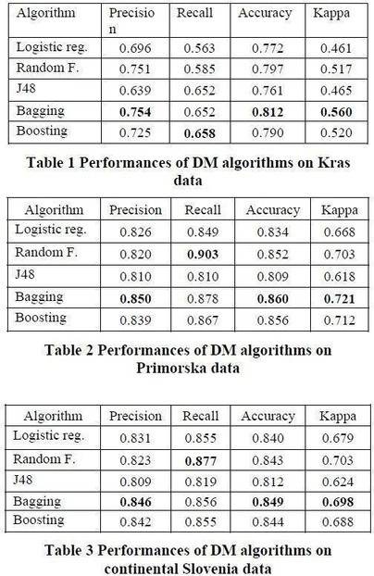

Table 2.1: Performances in Terms of Accuracy, Precision and Kappa

This paper was a review on different papers to find out the advantages and

disadvantages of existing techniques like:

Artificial Neural Network- An Artificial Neural Network (ANN) is inspired by the way

biological nervous systems, such as the brain, process information.

Fuzzy logic- Fuzzy logic is an approach to computing based on "degrees of truth" rather than the

usual "true or false" (1 or 0).

1.4

Review on various approaches



Image Processing- Image processing is a method to convert an image into digital form and

perform some operations on it to extract some useful information from it.

Satellite Constellation- A group of artificial satellites with coordinated ground coverage,

operating together under shared control.

Multisensor Data Fusion- Multisensor data fusion is the combining of sensory data from

separate sources such that the resulting information is better than individual sources.

Intelligent system- An intelligent system is a computer system that uses infrared images

along with ANN with additional information from sensors which can make decisions.

This mode was to use a support vector machine for classification and regression. Large

computation

and

storage

requirements

increase

due

to

the

increase

in

the

number

of

training vectors, therefore parallel SVM is studied to increase the speed of computing.

Five different DM techniques, e.g. Support Vector Machines (SVM) and Random Forests,

and four distinct feature selection setups (using spatial, temporal, FWI components and

weather

attributes),

were

tested

on

recent

real-world

data

collected

from

the

northeast

region of Portugal. The forest Fire Weather Index (FWI) is the Canadian system for rating

fire

danger

and

it

includes

six

components:

Fine

Fuel

Moisture

Code

FFMC),

(

Duff

Moisture Code (DMC), Drought Code (DC), Initial Spread Index (ISI), Buildup Index

BUI) and FWI.

(

The proposed solution, which is based on SVM and requires only four direct weather

inputs (i.e. temperature, rain, relative humidity and wind speed), is capable of predicting small

fires. This procedure indicates that all weather conditions affect the model, with the outside

temperature being the most important feature, followed by the accumulated precipitation.

1.6

Parallel SVM Based on MapReduce

1.5

Data Mining Approach to predict burned area of Forest Fires

The large dataset is first handled using mapreduce. Mapreduce is an efficient distributed computing model to process large scale data mining problems. Mapreduce is developed in software tools like Hadoop and Twisters. Hadoop and Twisters are open source mapreduce software. Mapreduce in Hadoop does not support iterative map reduce tasks. Twisters support both iterative and non-iterative map reduce and combine tasks. Many SVM software models have been developed like, libSVM, lightSVM, ls-SVM and so on. LibSVM is taken as the most efficient SVM model and widely applied in practice because of its excellent property. Using parallelization, training samples are divided into subsections. Each subsection is trained with a libSVM model. The non-support vectors are filtered with subSVMs. The support vectors of each subSVM are taken as the input of the next layer subSVM. The global SVM model will be obtained through iteration. This shows that parallel SVM along with MapReduce reduces the computation time.

# 1.7Artificial neural networks and logistic regression to predict forest fire danger

A model based on the Galician region (north-western Spain) has been proposed and image MODIS was used to track the status and the acquiring land surface temperature (LST). The following have been found: LST 8 days, fire and year history. The LST is an important parameter because higher temperatures correlate with lower humidity, which enables vegetation to ignite In order to assess forest fire hazards from remote sensing and fire history data, artificial neural network (ANN) and logistics regression were used for this work. The land surface temperature and EVI (Enhanced Vegetation Index) were remote sensing inputs used. Different input combinations with logistic regression have been tested. In an artificial neural network, combinations of variables have been implemented and results obtained by the two techniques have been compared. Increased accuracy and recall in artificial neural networks compared to logistic regression. This description was helpful in determining maps of fire hazards that can prevent fires.



1.10

Summary

1.8

Forest Fire Danger Index Using Geo-Spatial Techniques

1.9

Mapping regional forest fire probability using artificial neural network

K V Suresh Babu [5] provides a comprehensive explanation of various worldwide indices

of forest fire conditions, groups of forests and their areas, classification of different rates of

hazards, fire accidents in various classes of land cover, level of fire danger of different

types of property, categories of vegetation fire accidents, fire hazards for Uttarakhand

vegetation categories. In addition, he has described different class and FWI rating systems,

such as the Canadian Forest Fire Danger Rating System, the Canadian Fire Risk Index

System and the National Fire Danger Rating System. The different forms of forest in India

are also being studied. We plan to use his work to measure forest fire weather indicators

and measure fire hazard rates thresholds to improve the performance and accuracy.

A comparison on the pros and cons of the different algorithms like Linear regression,

Support

vector

machine,

non-linear

regression,

Random

forest,

Artificial

neural

networks and parallel support vector machine that were used in the previous works have

been discussed below in Table 2.2.

The Multi-Layer perceptron (MLP) techniques based on back propagation algorithms for

data on physical, climate, anthropogenic and fire incident facts were explored by Onur

Satir [9] et al. in the Mediterranean forest in Turkey. It was concluded that each area

should be studied separately for exact fire risk maps in order to accurately track risks

posed

by

forest

fires

with

the

most

concise

features

being

tree

canopy

covering,

temperature

and

Digital

Elevation

Map

(

DEMs)

and

according

to

cause

of

fire,

vegetation dynamic, climatic conditions and physical environment structures.



Non-

Linear

Regression

The dependent variables

act

as

a

nonlinear

part

of

model

parameters

and

one

or

more

independent

variables.

It

typically

generates

a

curve

where

Y

is

a

random

variable.

It

is

more

complex

to

develop

because

it

uses

multiple iterations.

2

𝑖

The equation is of

the form,

Y = f(X,

β

+

)

ε

Transformed to

intrinsically linear

Y =

θ

1

+

θ

/X

2*1

Well deals

with small

datasets and

effectively

uses

information

to predict

unknown

parameters

The

most

productive

model

research

can

be

established

because

the

experimental

information does

not

have

concrete

cinematic values.

Table 2.2: Comparison of different Methodology with pros and cons

Algorithm Key Idea

Formulas

The equation is of

the form,

Y= a +b X,

Pros

Simple and

easy to

implement

Cons

Most

problems

in

the real world are

not

linear

and

are not realistic

Linear

Regression

Method for linking

independent variables

with dependent variables

and finds a linear

relationship between

them. It aims to find the

value of Y such that the

difference between the

predicted value and the

actual value is minimum.

The cost function can be

used to find the best

values for and which

provides the best fit line

for the points.

Where Y is

dependent variable

and X is

independent

variable

The cost function is

given by,

𝑛

𝑖

𝑖=0

𝐶

1

=

∑(𝑝𝑟𝑒𝑑

𝑛

𝑌

)

−



Random

Forest

Many decision trees

act as a group in

which each

individual decision

tree gives a class

To make a prediction at a new

point x then,

fˆB(x) =1/B

Σ

(b1, B) (Tb(x)).

Where Tb is the random forest

tree and we take the average of B

Works well

for large

datasets and

avoids

overfitting

problems by

averaging or

combining

decision tree

results.

prediction, and this is such trees.

the final prediction

for the class with the

highest votes. There

is low correlation

between the

trees/models and the

predictions are more

accurate

Artificial Similar to how the

In general if there are n variables

then the equation for ANN will

be

f(x)=b+w1

⋅

x1+w2

⋅

x2+...+wn

⋅

xn

where w is the weights and x is

It is durable,

versatile and

can be used

in complex

designs. The

result is

obvious

neural

networks

brain has

interconnected

neurons and

processes

information, we have the data points.

multiple

interconnected

elements that work

together

simultaneously to

solve a problem.

They are multi-layer

connected nets.

There are three

layers, the input

layer, hidden layer

and output layer.

Requires

high data

and the

chances

of over-

fitting are

high

Random

forests are

difficult

to

construct

and

timely



Support

Vector

Machine

Parallel

Support

Vector

Machine

Every data component is The hyperplane

Functions

well

in large spaces.

It is efficient in

If

the

number

of

features

is

much

greater

than the

drawn as one point in an

n-dimensional space and using the

can be found

a hyperplane can be

defined to differentiate

between the classes by

maximizing its margin.

Having maximum

margin between the

support vectors and

hyperplane is important

as this will ensure

accurate predictions.

Parallel methods for

large scale classification

are implemented to

speed up the SVM

process. Here the model

has multiple SVMs

working in parallel on

divided datasets. Each

SVM will produce

support vectors which

will be sent to another

set of SVMs. This will

continue till we get a

refined set of support

vectors which will not

change further.

equation:

memory because number of samples,

it

support

vectors which

form

part

of

a

chances of over-

fitting are possible.

No memory and

processing time

Portable.

w.x+b = 0,

where w is the

normal vector to group of

the

hyperplane

and x is the set

of

points.

The

width

of

the

margin is (2/|w|)

SVM is

implicitly

parallelized to

get smaller SV

sets.

Parallelizing

SVM with split

dataset to get

refined set of

support vectors

training vectors.

Reduces

memory

from O(n2)

to O(np/m)

and improves

computation

time to

O(np2/m)

Where n is the

number of

instances, p is

the reduces

matrix and m is

the number of

machines

Reformulations are

too memory

intensive.



CHAPTER 3

SYSTEM REQUIREMENTS SPECIFICATION

Functional Requirement defines a function of a software system and how the system

must

behave

when

presented

with

specific

inputs

or

conditions.

These

may

include

calculations, data manipulation and processing and other specific functionality.

●

To create a machine learning model to predict forest fires using SVM technique and

LIBSVM model.

●

To increase the computational speed we use parallel SVM.

●

To create a user interface for predicting forest fires and sending an alert message to

authorities like the Ministry of Environment, Forest, Climate Change (MOEFCC).

Non- Functional Requirement defines the performance of a software system and how scalable

and reliable the system is and it includes scalability, recoverability, availability, capacity etc.

SRS is a document that completely describes what the proposed software should do

without describing how the software will do it. It’s a two-way insurance policy that

assures that both the client and the organization understand the other’s requirements

from that perspective at a given point in time. Requirement is a condition or capability

to which the system must conform. Requirement Management is a systematic approach

towards eliciting, organizing and documenting the requirements of the system clearly

along with the applicable attributes.

3.1

Functional Requirements

3.2

Non-Functional Requirements



●

Processors: Intel i3,i5,i7

●

Processor Speed: 3.00GHZ

●

RAM: 4GB

●

Storage: 50GB

●

Monitor: 15inches

●

Keyboard: Standard 102 keys

●

Mouse: Standard 3 buttons

●

Operating System can be either Windows 7,8,9,10, XP

●

Pandas, Numpy, Sklearn, Pyspark, Matplotlib modules in python

●

Jupyter notebook

●

Pyspark for implementing Parallel SVM, Binary and Multi class evaluator modules

●

Visual studio Code

●

Django

●

To give a user-friendly experience using the user interface to check and test the dataset.

●

It can be used in real-world using real-time meteorological data.

●

To make the application extremely scalable.

●

To test the application and ensure maintainability on a timely basis.

3.3

Hardware Requirements

3.4

Software Requirements

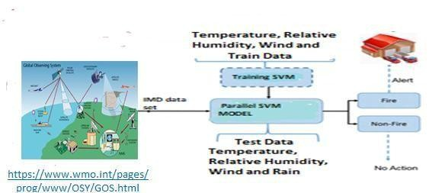

CHAPTER 4

SYSTEM ANALYSIS AND DESIGN

Fig 4.1: System Architecture

We have used Django web framework to build the UI for this predictor model. The

implementation framework is discussed in detail in this section. Data set is collected

from IMD to train and test the model. Based on our literature survey we will be using

SVM to predict forest fires. SVM is best for small fires and parallel SVM model is

implemented to make the predictions accurate and fast. A detailed explanation about

the model and how it is implemented is discussed in the below section.

4.1

System Architecture



As shown in Fig 4.1, the IMD dataset is fed as input to the Forest fire detection system

implemented using Parallel SVM wherein the dataset contains only the basic attributes like

Temperature,

Relative

humidity,

Wind

and

Rain.

Then

the

data

is

processed

by

calculating the Fire Weather Indices (FWI). After the data processing, the model is trained

using the train data and for testing purpose, the test data is fed with the same attributes as

the train data. The model produces a result based on whether Fire happened (Fire =1) or

not. If the output contains Fire = 1, then an alert is sent to the forest department and other

concerned departments to take the necessary actions.

URLs: A URL mapper is used to redirect HTTP requests to the appropriate view

based on the request URL. The URL mapper can also match particular patterns of

strings or digits that appear in a URL and pass these to a view function as data.

View:

A

view

is

a

request

handler

function,

which

receives

HTTP

requests

and

returns

HTTP responses.

Forest Fire: Model in Python that will run when the dataset is uploaded by the

front

end user.

Fig 4.2 is a web application using Django web framework. Like in a traditional data-

driven website, a web application waits for HTTP requests from the web browser (or

user). When a request is received the application works out what is needed based on the

URL

and

possibly

information

in

POST

data

or

GET

data.

Depending

on

what

is

required it will perform tasks required to satisfy the request, in this case it will take the

file uploaded and will run the programs in the background to predict forest fires. The

application will then return a response to the web browser, often dynamically creating an

HTML page for the browser to display by inserting the retrieved data into placeholders

in an HTML template.

Django web applications typically group the code that handles each of these steps into

separate files:

4.2

Implementation Framework

●

●

●

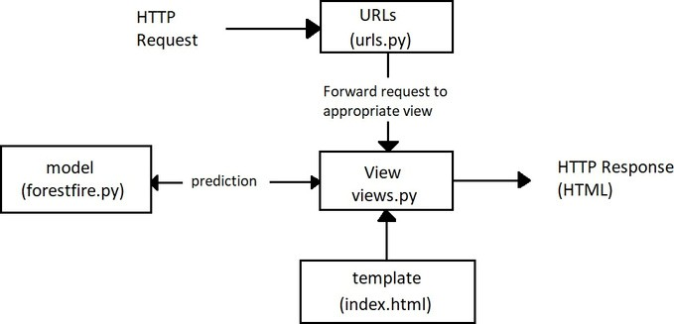

●

Fig 4.2: Django implementation Framework

Templates: A template is a text file defining the structure or layout of a file (such

as an HTML page), with placeholders used to represent actual content. A view

can dynamically create an HTML page using an HTML template, populating it

with data from our program. This acts as the client side.

The dataset is collected from Indian Meteorological department (IMD). The four basic

attributes considered are: Temperature, Wind, Rainfall and Relative humidity. From these

basic

parameters,

fuel

moisture

codes

like

Ffmc

(

fine

fuel

moisture

code),

DMC

(

duff

moisture

code),

DC

(

drought

code)

and

fire

behaviour

indices

like

ISI

(

initial

spread

index), BUI (buildup index) and FWI (fire weather index) are calculated where the derived

attributes are a function of

4.3

Dataset



the basic attributes as shown below:

●

FFMC is a function of Temperature, Relative humidity, Rain and Wind.

●

DMC is a function of Temperature, Relative humidity and Rain

●

DC is a function of Temperature and Rain

●

ISI is a function of ffmc, wind

●

BUI is a function of ffmc, dmc

●

FWI is a function of ISI and BUI

Code:

***def***

***main***

***():***

***h=[***

***"Year"***

***,***

***"Month"***

***,***

***"Day"***

***,***

***"FFMC"***

***,***

***"DMC"***

***,***

***"DC"***

***,***

***"ISI"***

***,***

***"BUI"***

***,***

***"Temp"***

***,***

***"RH"***

***,***

***"Wind"***

***,***

***"Rain"***

***,***

***"FWI"***

***,***

***"Intensity"***

***,***

***"Fire"***

***]***

***hd=***

***','***

***.j***

***oin(h)***

***f_out.write(hd)***

***f_out.write(***

***"***

***\r***

***"***

***)***

***for***

***line***

***in***

***f_in:***

***l=line.rstrip().split(***

***','***

***)***

***import***

***sys***

***ffmc0=***

***85.0***

***dmc0=***

***6.0***

***dc0=***

***15.0***

***my_csv_in = sys.argv[***

***1***

***]***

***with***

***open***

***(***

***my_csv_in,***

***'r'***

***)***

***as***

***f_in:***

***print***

***(***

***"opened"***

***)***

***next***

***(***

***)***

***f_in***

***with***

***open***

***(***

***'/Users/krsingh/Desktop/datasets/testset3.csv'***

***,***

***'w'***

***)***

***as***

***f_out:***



These factors affect the occurrence of Forest fire in various ways:

●

Relative Humidity: When the relative humidity is 40 percent, it means that the

atmosphere contains 40 percent of the moisture that it could contain at that same

temperature. When the humidity is high, it’s harder for the moisture to evaporate into

the air. Consequently, high humidity acts like a damper on a stove. If the humidity is

100

percent or close to it, the fuel will not dry. On the other hand, the lower the relative

humidity, the quicker the moisture will evaporate. The lower the relative humidity, the

more readily a fire will start and burn; the more vigorously a fire will burn.

***m***

***th=l[***

***1***

***]***

***day=l[***

***2***

***]***

***temp=***

***float***

***(***

***l***

***[***

***3***

***])***

***rhum=***

***float***

***(***

***l***

***[***

***4***

***])***

***wind=***

***float***

***(***

***l***

***[***

***5***

***])***

***prcp=***

***float***

***(***

***l***

***[***

***6***

***])***

***if***

***rhum>***

***100.0***

***:***

***rhum***

***=***

***100.0***

***mth=***

***int***

***)***

***mth***

***(***

***fwisystem=***

***FWICLASS(temp,rhum,wind,prcp) ffmc =***

***fwisystem.FFMCcalc(ffmc0)***

***dmc =***

***fwisystem.DMCcalc(dmc0,mth) dc =***

***fwisystem.DCcalc(dc0,mth) isi =***

***fwisystem.ISIcalc(ffmc)***

***bui = fwisystem.BUIcalc(dmc,dc)***

***l=[***

***str***

***yr),***

***(***

***str***

***(***

***mth),***

***str***

***(***

***day),***

***str***

***(***

***round***

***(***

***ffmc,***

***4***

***))***

***,***

***str***

***(***

***round***

***(***

***dmc,***

***4***

***))***

***,***

***str***

***(***

***round***

***(***

***dc,***

***4***

***,***

***))***

***str***

* Temperature: Air temperature has a direct influence on fire behaviour because of the heat requirements for ignition and continuing the combustion process. Forest fuels receive heat by radiation from the sun. As a result, less heat is required for ignition. The differential heating of the earth’s surface is the driving force behind most of the influences on the atmosphere. The sun emits short-wave energy rays (radiation). When striking a solid object such as trees or grass, it is warmed. Temperature is the most important weather factor affecting fire behaviour. Warm fuels will ignite and burn faster because less heat energy is used to raise the fuels to their ignition temperature. Fuels exposed to sunlight will be warmer than the fuels in shade. They will also be drier. For this reason, fuels not shaded by an overstory will generally be warmer and drier resulting in a more intense fire.
* Wind: Wind increases the supply of oxygen, which results in the fire burning more rapidly. It also removes the surface fuel moisture, which increases the drying of the fuel. Air pressure will push flames, sparks and firebrands into new fuel. By pushing the flames closer to the fuel in front of the fire, the fuel is preheated quicker because
* of the increased radiant heat discussed previously. More of the fuel becomes available for combustion since it is dryer and can reach ignition temperature quicker. Rain: Precipitation (rain or snow) has a direct and immediate effect on fuel moisture and relative humidity. Temperature usually drops as well and the winds become calm. When the atmosphere becomes saturated, precipitation usually occurs if more moisture is added. Precipitation will quickly dampen the surface of fuels to the point that fires cannot ignite and no wildfires will occur. Rain can prevent back-burning, making it harder to build control lines and lead to patchy burnt areas that can flare up again. For rain to extinguish the fires, it will require inches of steady falls over an extended period. As the vegetation greens-up, prescribed burning conditions may deteriorate. If, however, a winter drought occurs and continues into the spring, fires will readily burn on into the summer because of the larger amount of dead, dry fuel and low fuel moisture. These fires may be more difficult to control and do more damage due to burning deeper into the litter and

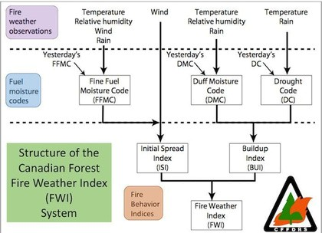

Fig 4.3: Structure of FWI System

consuming larger size fuel. During long periods of dry weather, drought, moisture

that is toward the centre of larger fuels and deeper in surface litter is able to work

its way to the surface and evaporate into the dry atmosphere. As a result, a larger

percent of the total fuel becomes available fuel; available to burn.

●

FFMC: This index classifies the moisture content of litter and other cured fine fuels,

like needles or twigs less than 1 cm in diameter. FFMC is representative of the top

litter

layer

1-2

cm

deep

and

has

a

short-term

memory,

only

reflecting

weather

conditions that have occurred over the past three days.

●

DMC:

This

index

indicates

the

moisture

content

of

loosely

compacted

organic

layers with a depth of 5-10cm. DMC fuels have a slower drying rate than FFMC fuels

and DMC may be used in predicting the probability of fire ignition by lightning.

●

DC: reflects the moisture content of compact organic layers, 10-20cm deep. It is an

indicative long-term moisture condition and deep burning fires.

●

ISI: this index combines FFMC and wind speed being a good indicator for fire spread.

●

BUI: represents the total fuel available for the spreading of fire.

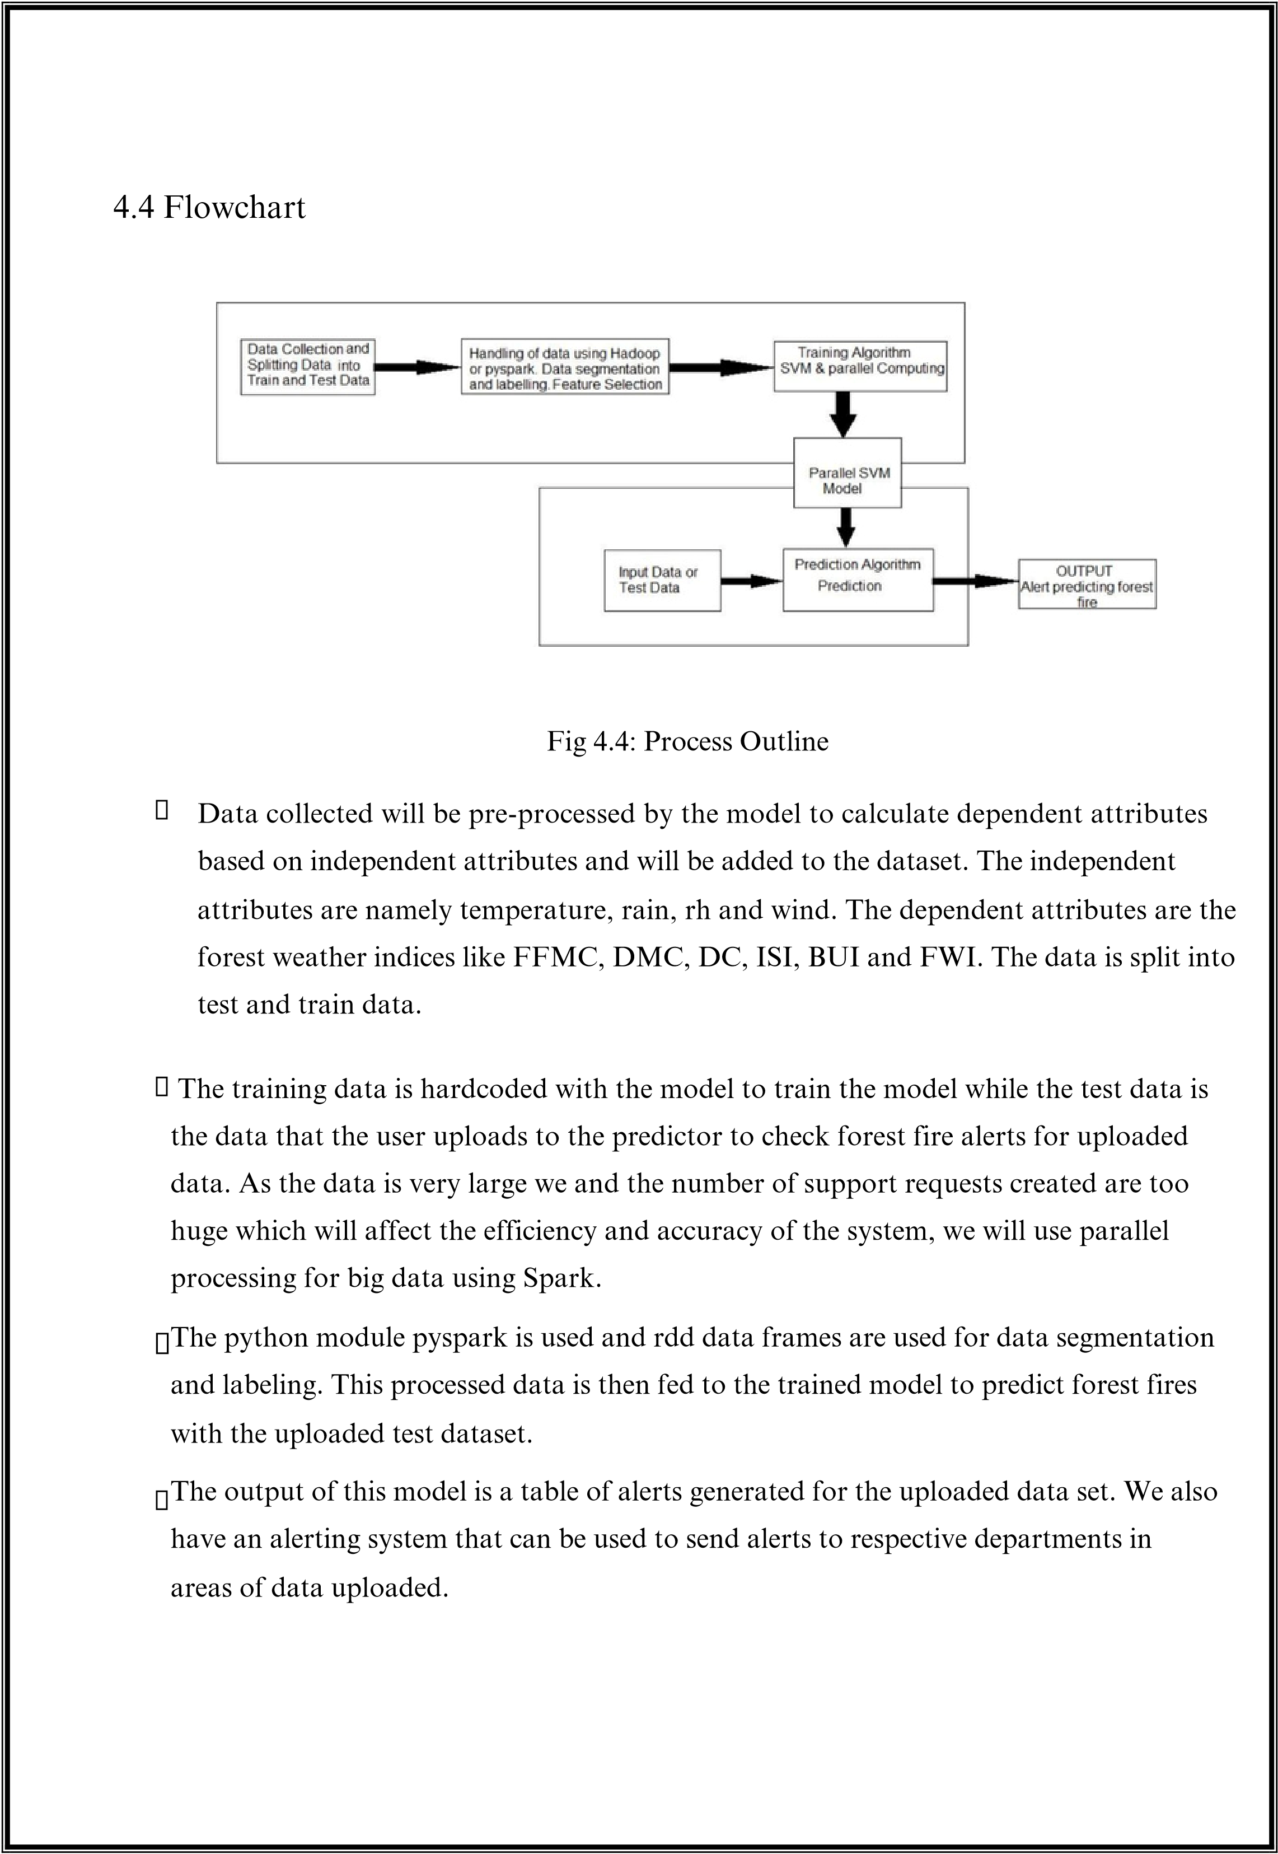

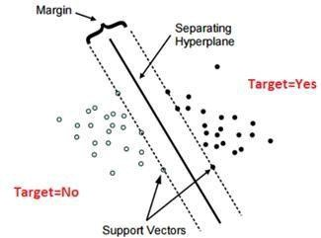

CHAPTER 5

IMPLEMENTATION

5.1

Support Vector Machine

Fig 5.1: Support Vector Machine

Support

vector

machine

is

a

supervised

learning

algorithm

which

can

be

used

for

classification and regression. In SVM, the data is represented in an n-dimensional space

where it can predict whether a new training example falls into the same category or a

different category. The main aim of SVM is to find a hyperplane in the n- dimensional

space

that

can

clearly

classify

the

data

points.

There

are

several

potential

hyperplanes

which

could

be

chosen

to

distinguish

the

two

classes

of

data

points.

But

the

ideal

hyperplane is the one that maximizes the margin i.e. the maximum distance between data

points

of

both

classes

as

shown

in

Fig

5.1

.

Hyperplanes

are

boundaries

for

decision

making which help to distinguish data points. Data points which fall on either side of the

hyperplane can be attributed to various classes. The dimension of the hyperplane depends

upon the number of features.

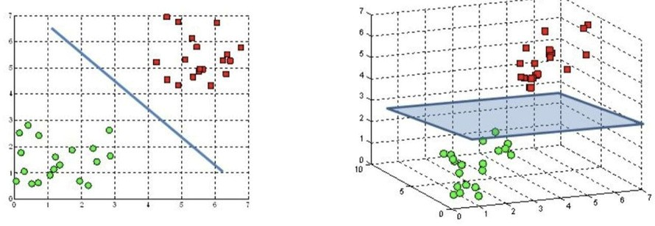

Fig 5.2: Hyperplanes in 2D and 3D

Support vectors are data points that are closer to the hyperplane and influence the

position and orientation of the hyperplane. Using these support vectors, we maximize the

margin of the classifier. Deleting the support vectors will change the position of the hyperplane.

These are the points that help us build our SVM.

As shown in Fig 5.1, Support vectors are the data points that are closer to the hyperplane.

They influence the position and orientation of the hyperplane. These support vectors play

a major role in classifying the data points to different classes.

Hyperplanes are decision boundaries that help classify the data points. Data points

falling on either side of the hyperplane can be attributed to different classes. Also, the

dimension of the hyperplane depends upon the number of features. If the number of input

features is 2, then the hyperplane is just a line. If the number of input features is 3, then the

hyperplane becomes a two- dimensional plane like in Fig 5.2. It becomes difficult to imagine

when the number of features exceeds 3.

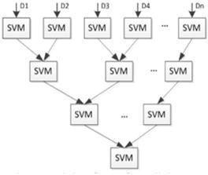

Fig 5.3: Parallel Support Vector Machine

(

)

Figure taken from paper

A major disadvantage of SVM is that it does not perform well when the training set is

large in size as the storage and compute requirements increase with increase in the training

vectors. Hence, Parallel SVM can be used in order to reduce the computational time and

improve the performance.

The parallel SVM is based on the Cascade SVM model. The SVM is trained through

partial

SVMs.

Each

subSVM

is

used

as

a

filter

which

takes

us

towards

the

global

optimum.

Using

the

Parallel

SVM

model,

large

scales

of

data

can

be

divided

into

smaller, independent sub data. The former subSVMs support vectors are used as the

input to the later subSVMs as shown in Fig 5.3.

The support vectors of two SVMs are combined into one set and sent as input to a new

SVM. This process is continued until a single set of vectors is left which is the global optimum.

The size of the training set is reduced in each subsequent stage. Each subSVM is trained with

a SVM model like libSVM, lightSVM etc. Most efficient SVM model is libSVM.

5.2

Parallel Support Vector Machine

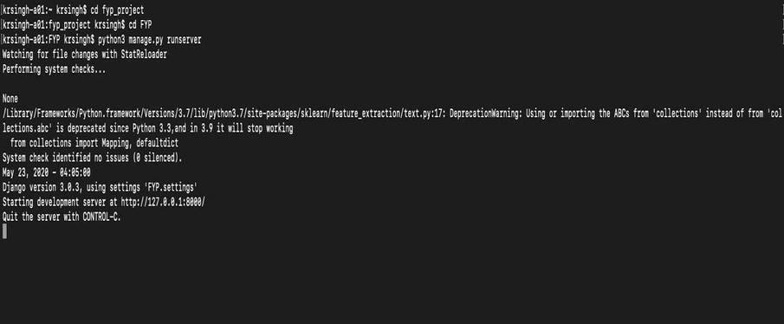

Fig 5.4: Command Prompt

Explicit

parallelization

approaches

parallelize

the

computation

within

each

iteration

as

well as parallelizing kernel computations. Parallelize reduces the number of working sets

for

the

model

thereby

speeding

up

the

testing

process

and

making

it

more

efficient

in

predictions. Parallelizing the SVM is a method where the huge dataset of 30 years data will

be divided into smaller datasets and is fed into multiple SVMs simultaneously that outputs

a set of support vectors along with the another set of support vectors are fed into another

SVM. This is done until we get one set of support vectors that have maximum margin from

the

hyperplane

which

will

make

this

model

more

reliable

and

will

predict

with

better

accuracy and efficiency. To achieve this we will use spark for big data computing and rdd

datasets

for

parallel

computing

in

our

program.

Forest

fires

could

be

due

to

multiple

reasons; it is very difficult to make a prediction system. There could be multiple reasons

for forest fires, what we want to achieve using our model is a reliable system that could

predict correctly based on weather conditions if fire occurs and also the intensity of fire.

The python manage.py run server command is executed in the Django project

directory as shown in Fig 5.4 and the page appears in the localhost URL.

5.3

Front-end and Back-end implementation details



Handling the requests (view.py)

Views are the heart of the web application, receiving HTTP requests from web clients

and returning HTTP responses. In between, they marshall the other resources of the

framework to access databases, render templates, etc.

Sending request to the right Url (url.py)

A URL mapper is typically stored in a file named urls.py. In the example below, the

mapper (urlpatterns) defines a list of mappings between routes (specific URL patterns)

and

corresponding

view

functions.

If

an

HTTP

Request

is

received

that

has

a

URL

matching a specified pattern then the associated view function will be called and passed

the request.

Code

Code

The first argument to both methods is a route (pattern) that will be matched. The path()

method uses angle brackets to define parts of a URL that will be captured and passed

through to the view function as named arguments.

***]***

***from***

***subprocess***

***import***

***run, PIPE ,Popen, call,check_output***

***def***

***button***

***(***

***request***

***):***

***return***

***render(request,***

***'index.html'***

***)***

***def***

***output***

***(***

***request***

***):***

***return***

***render(request,***

***'index.html'***

***)***

***urlpatterns = [***

***re_path(***

***r***

***'^admin/'***

***, admin.site.urls),***

***re_path(***

***r***

***'^$'***

***, views.button),***

***re_path(***

***r***

***'^output'***

***,views.output,***

***name***

***=***

***'script'***

***,***

***)***

***re_path(***

***r***

***'^external'***

***,views.external),***

***re_path(***

***r***

***'^alert/'***

***,views.alert,***

***name***

***=***

***"alert"***

***,***

***)***

***re_path(***

***r***

***'^prediction/'***

***,views.prediction,***

***name***

***=***

***"prediction"***

***)***

***, re_path***

***(***

***r***

***'^validation/'***

***,views.validation,***

***name***

***=***

***"validation"***

***,***

***)***

***name***

***=***

***"predictor"***

***)***

***re_path(***

***r***

***'^predictor/'***

***,views.predictor,***



The definition of the model is independent of the underlying database and in our model it

runs the predictor algorithm when the test dataset gets uploaded on the predictor page of

UI. The view external() gets called when the file gets uploaded and the model predicts the

results for the dataset uploaded.

Code

Defining model(foresfire.py)

***def***

***alert***

***(***

***request***

***):***

***return***

***render(request,***

***'pg2.html'***

***)***

***def***

***prediction***

***(***

***request***

***):***

***return***

***render(request,***

***"prediction.html"***

***)***

***def***

***validation***

***(***

***request***

***):***

***return***

***render(request,***

***"validation.html"***

***)***

***def***

***predictor***

***(***

***request***

***):***

***return***

***render(request,***

***"index.html"***

***)***

import

pyspark

from

pyspark.sql

import

SparkSession

from

pyspark.ml

import

Pipeline

from

pyspark.ml.feature

import

StringIndexer

from

pyspark.ml.feature

import

VectorAssembler

from

pyspark.ml.evaluation

import

***def***

***external***

***(***

***request***

***):***

***file***

***=***

***[***

***request.FILES***

***'myfile'***

***]***

***f=***

***"/Users/krsingh/Desktop/datasets/"***

***+***

***str***

***(***

***file***

***)***

***output=Popen([***

***'python3'***

***,***

***'/Users/krsingh/fyp_project/FYP/FYP/forestfire.py'***

***,f],***

***stdout***

***=***

***P***

***IPE,***

***universal_newlines***

***=***

***True***

***)***

***l=[]***

***for***

***line***

***in***

***output.stdout.readlines():***

***l.append(line)***

***print***

***(***

***len***

***(***

***l***

***))***

***return***

***render(request,***

***'index.html'***

***,***

***{***

***'Accuracy_LSVM'***

***:***

***[***

***l***

***1***

***,***

***]***

***'Precision_LSVM'***

***:***

***l***

***[***

***2***

***,***

***]***

***'Recall_LSVM'***

***:***

***l***

***[***

***3***

***]***

***,***

***'Time_LSVM'***

***:***

***l***

***[***

***4***

***,***

***]***

***'Accur***

***acy_PSVM'***

***:***

***l***

***[***

***5***

***]***

***,***

***'Precision_PSVM'***

***l***

***:***

***[***

***6***

***]***

***,***

***'Recall_PSVM'***

***l***

***[***

***:***

***7***

***]***

***,***

***'Time_PSVM'***

***[***

***l***

***:***

***8***

***]})***



#import Spark and MLlib packages

from

pyspark

import

SparkContext, SparkConf

from

pyspark.mllib.regression

import

LabeledPoint

from

pyspark.mllib.classification

import

SVMWithSGD, SVMModel

from

pyspark.mllib.classification

import

LogisticRegressionWithLBFGS

#import data analysis packages

import

numpy

as

np

import

pandas

as

pd

import

sklearn

from

pandas

import

Series, DataFrame

from

sklearn

import

svm

from

sklearn.svm

import

SVC

from

sklearn.cross_validation

import

train_test_split

from

sklearn

import

metrics

from

numpy

import

array

from

timeit

import

default_timer

as

timer

#import data visualization

packages

import

matplotlib.pyplot

as

plt

import

seaborn

as

sns

sns.set_style(

'whitegri

d'

)

import

random

dataframets= pandas.read_csv(

r

"/Users/krsingh/Desktop/datasets/testset3.csv"

)

dataframetr =

pandas.read_csv(

r

"/Users/krsingh/Desktop/datasets/newtraintdata7.csv"

)

featuredatatr=dataframetr.iloc[:,

:

14

]

targetvaluestr=dataframetr.iloc[:,

14

:]

featuredatats=dataframets.iloc[:,

:

14

]

targetvaluests=dataframets.iloc[:,

14

:]

x_train=featuredatat

r

x_test=featuredatats

y_train=targetvalues

tr

y_test=targetvaluest s

# SVM regularizaion

parameter

C =

1.0

svc = svm.SVC(

kernel

=

'linear'

,

C

=

C).fit(x_train, y_train

)

start = timer()

predicted =

svc.predict(x_test) end

=

timer

()



Rendering data using templates (index.html)

Templates are often used to create HTML and code snippets show what the HTML template

called by the render() function in the previous section might look like.

predicted = svc.predict(x_test)

expected = y_test

from

pyspark.ml

import

Pipeline

from

pyspark.ml.feature

import

StringIndexer

from

pyspark.ml.feature

import

VectorAssembler

from

pyspark.ml.evaluation

import

MulticlassClassificationEvaluator

from

pyspark.ml.feature

import

QuantileDiscretizer

from

pyspark.ml.classification

import

LinearSVC

from

pyspark.ml.evaluation

import

BinaryClassificationEvaluator

spark = SparkSession \

.builder \

.appName(

"Spark ML example on data "

)

\

.getOrCreate()

datatrain=

"/Users/krsingh/Desktop/datasets/newtraintdata7.csv"

dftr = spark.read.csv(datatrain,

header

=

'True'

,

inferSchema

=

'True'

)

datatest=

"/Users/krsingh/Desktop/datasets/testset3.csv"

dfts = spark.read.csv(datatest,

header

=

'True'

,

inferSchema

=

'True'

)

featuretr = VectorAssembler

(

inputCols

=[

x

for

x

in

dftr.columns],

outputCol

=

'features'

)

feature_vector_tr= featuretr.transform(dftr)

featurets = VectorAssembler(

inputCols

=[

x

for

x

in

dfts.columns],

outputCol

=

'features'

)

feature_vector_ts= featurets.transform(dfts)

trainingData=feature_vector_tr

testData=feature_vector_ts

from

pyspark.ml.classification

import

LinearSVC

from

pyspark.ml.evaluation

import

BinaryClassificationEvaluator svm = LinearSVC(

labelCol

=

"Fire"

,

featuresCol

=

"features"

)

svm_model = svm.fit(trainingData

)

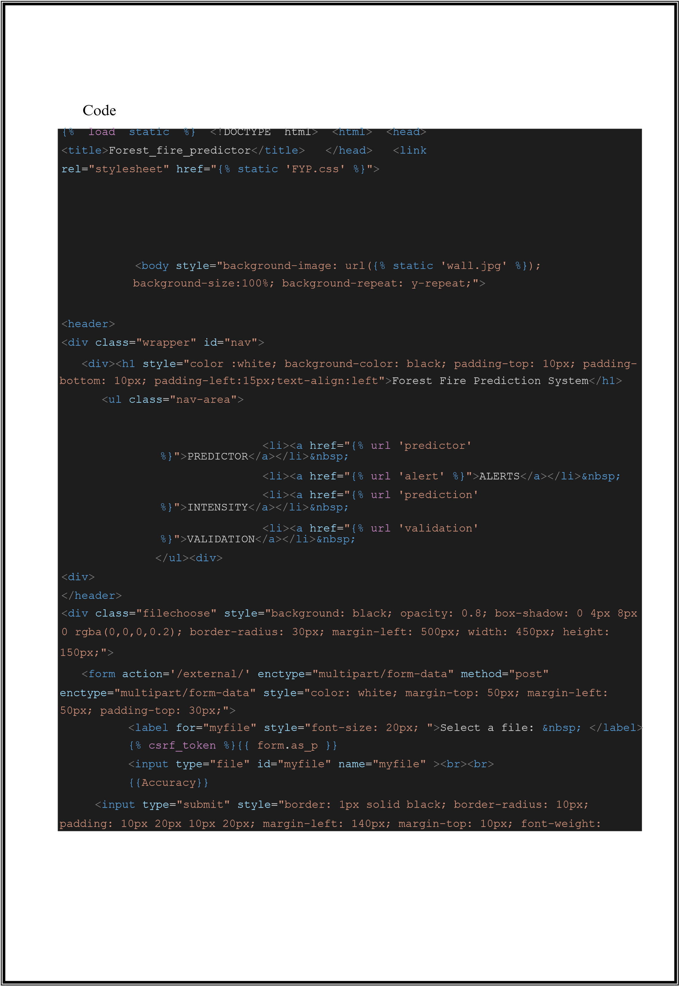

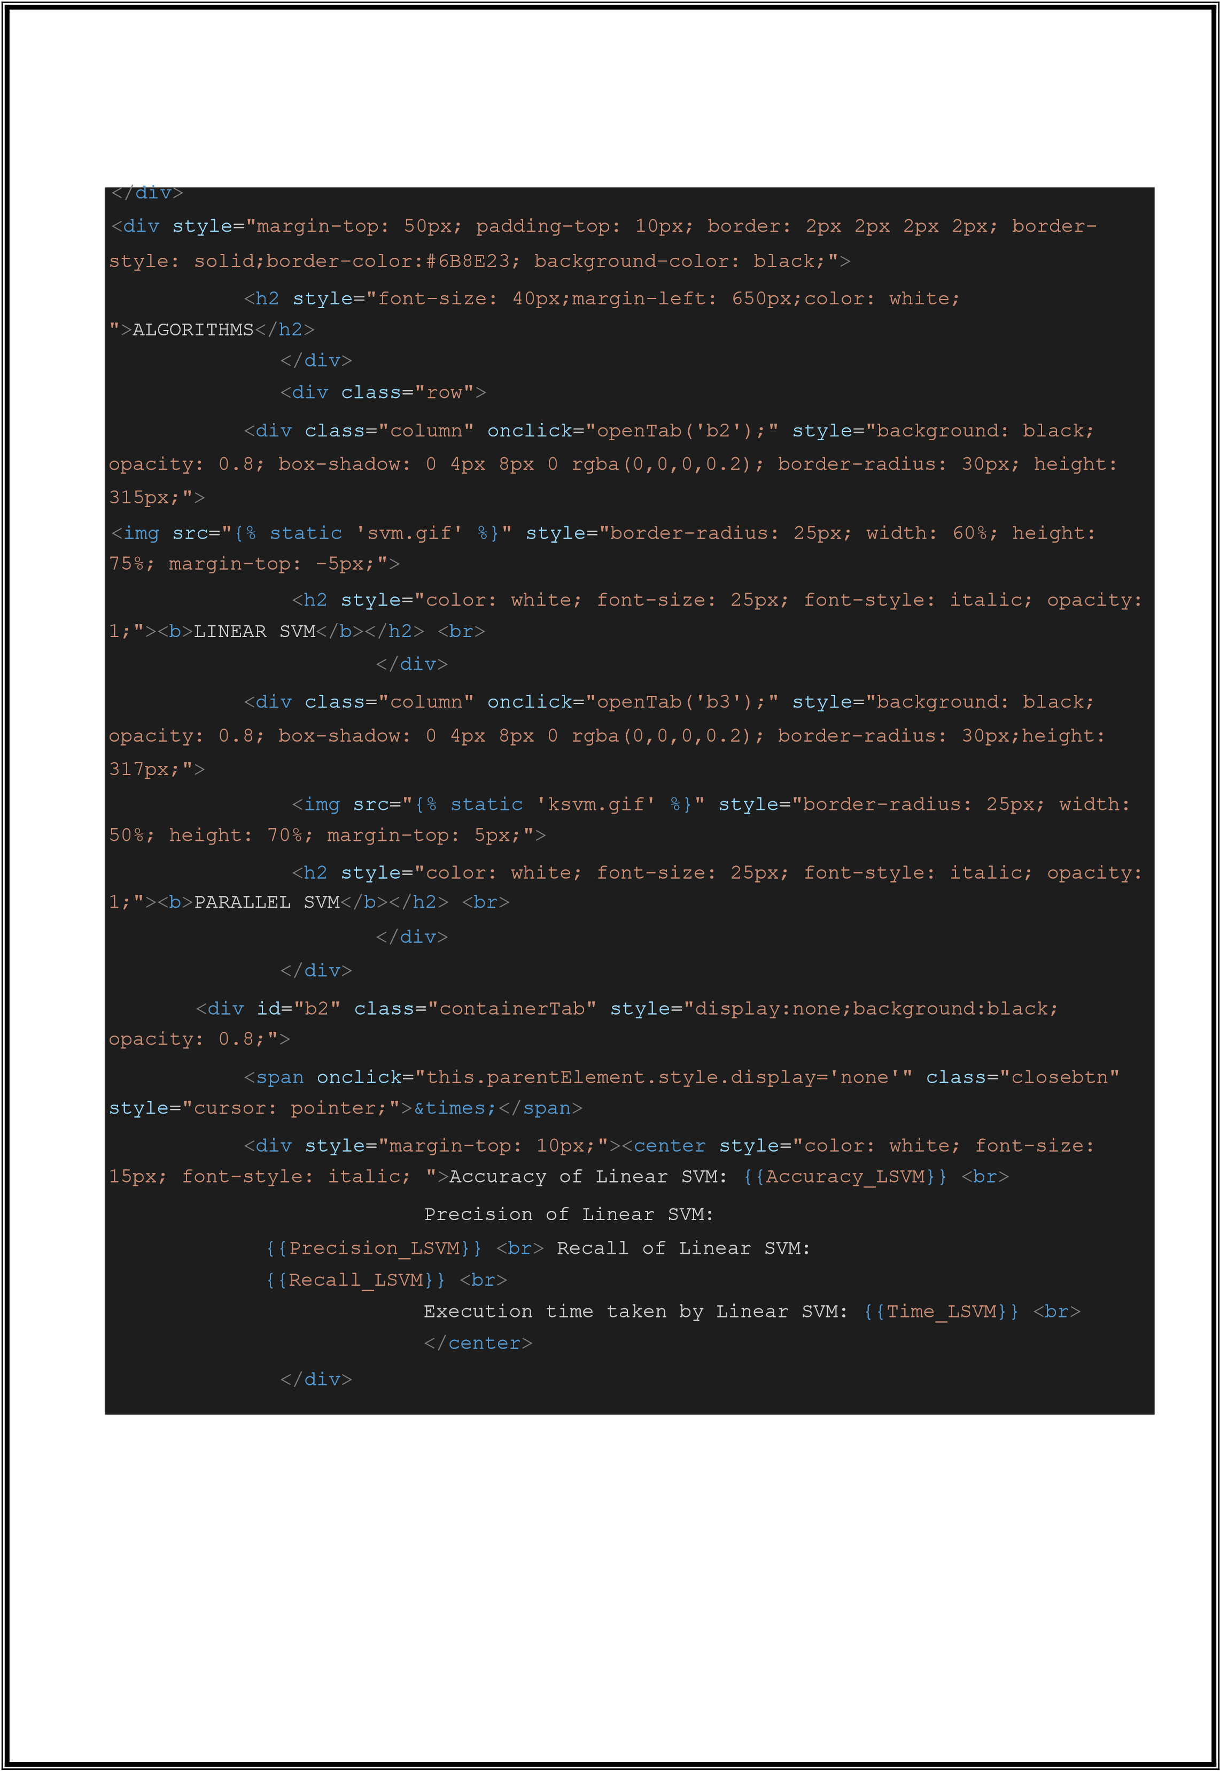

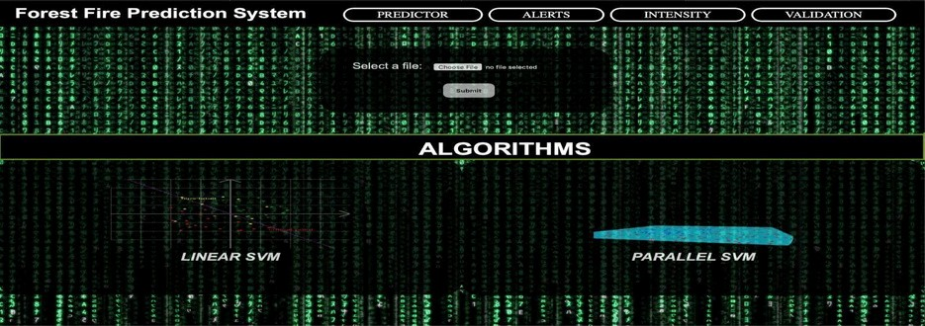

Fig 5.5: User Interface

The home page of our forest fire prediction system is shown in Fig 5.3 which contains

four tabs: Predictor, Alerts, Intensity and Validation. The dataset can be uploaded and

the results of two algorithms can be seen.

}

<

div

id

=

"b3"

class

=

"containerTab"

style

=

"display:none;background:black;

opacity: 0.8;"

>

<

span

onclick

=

"this.parentElement.style.display='none'"

class

=

"closebtn"

style

=

"cursor: pointer;"

>

&times;

<

/

span

>

<

div

style

=

"margin-top: 10px;"

><

center

style

=

"color: white; font-size:

15

px; font-style: italic; "

>

Accuracy of Parallel SVM:

{{

Accuracy_PSVM

}}

<

br

>

Precision of Parallel SVM:

{{

Precision_PSVM

}}

<

br

>

Recall of Parallel SVM:

{{

Recall_PSVM

}}

<

br

>

Execution time taken by Parallel SVM:

{{

Time_PSVM

}}

<

br

>

/

<

center

><

/

div

>

<

/

div

>

<

script

>

function

openTab

(

tabName

)

{

var

i

,

x

;

x

=

document

.

getElementsByClassName

(

"containerTab"

)

;

for

(

i

=

0

;

i

<

x

.

length

;

i

++) {

x

[

i

].

style

.

display

=

"none"

;



Triggered Alerts

The model has an automated alert system that gets triggered whenever the predictions are

made. The alerts are in tabular form and give the month day details for when the fire is

predicted and also the intensity of the fire based on the thresholds applied on the weather

indices.

Code

***from***

***email.mime.text***

***import***

***MIMEText***

***())***

***else***

***:***

***server = smtplib.SMTP(***

***'smtp.gmail.com'***

***,***

***587***

***)***

***server.starttls()***

***server.login(***

***"forestfire.alerts@gmail.com"***

***,***

***"**********"***

***)***

***from***

***email.mime.multipart***

***import***

***MIMEMultipart***

***import***

***smtplib***

***fromaddr =***

***"ForestfireAlerts.gmail.com"***

***toaddr = [***

***“whom so ever specified”***

***for***

***i***

***in***

***range***

***(***

***len***

***(***

***toaddr***

***)):***

***html =***

***open***

***(***

***"/Users/krsingh/fyp_project/FYP/FYP/template/pg2.html"***

***msg***

***=***

***)***

***MIMEMultipart()***

***msg[***

***'From'***

***=***

***]***

***fromaddr msg[***

***'To'***

***=***

***]***

***toaddr[i]***

***msg[***

***'Subject'***

***]***

***=***

***"Fire Alerts***

***Report"***

***part2 = MIMEText(html.read(),***

***'html'***

***msg.attach(part***

***2)***

***)***

***debug***

***=***

***False***

***if***

***debug:***

***print***

***(***

***msg.as_string***



CHAPTER 6

RESULTS AND DISCUSSION

Fig 6.1 (a): Linear SVM Results

The results are divided into 4 tabs: Predictor, Alerts, Intensity and Validation.

●

Predictor Tab:

A comparison of Linear SVM and Parallel SVM is shown.

Both algorithms are trained to predict forest fires. The accuracy of prediction,

precision, and recall values are displayed in the results.

The estimated time required for the algorithms to run is also displayed.

The results show a slight variation in the displayed values, thus proving the

higher efficiency of parallel SVM compared to linear SVM.

The accuracy, precision, and recall values for parallel SVM is higher than SVM.

Fig 6.1 (a) shows the results of Linear SVM and Fig 6.1 (b) shows the results

of Parallel SVM.

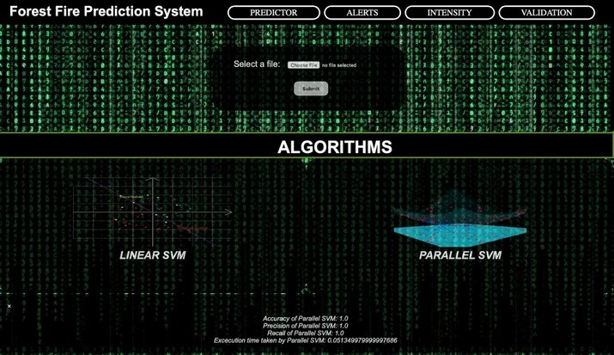

●

●

●

Fig 6.1 (b): Parallel SVM Results

A graph showing the predicted fire graph is plotted as shown in Fig 6.4 (a).

A graph showing the validation of our model with predicted and actual is

plotted as shown in Fig 6.4 (b).

In the second tab, a table of the data values is displayed.

These data values correspond to the entries where the occurrence of fire was

predicted as 1.

A column displaying the intensity of the fire is also displayed.

Fig 6.2 shows the Alert tab showing the predicted fire days.

A graph showing month wise occurrence of fire is plotted as shown in Fig 6.3.

Alerts tab:

Intensity Tab:

Validation Tab:

➢

➢

➢

➢

➢

➢

➢

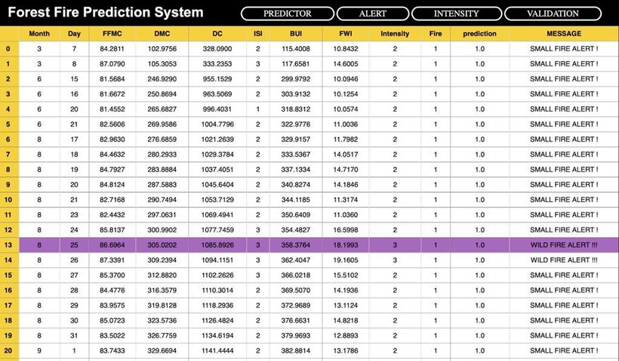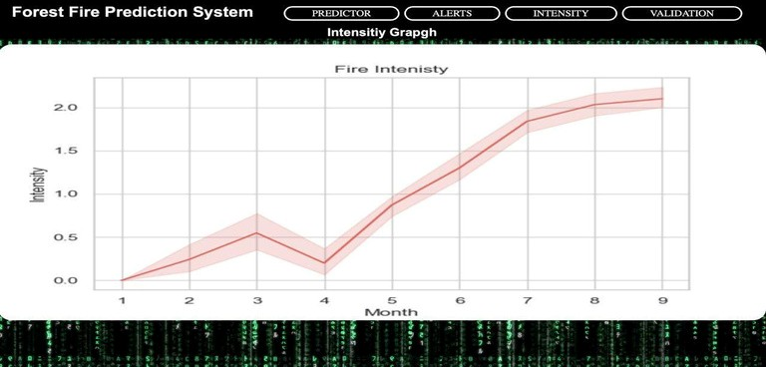

Fig 6.2: Predicted Fire Days

Fig 6.3: Fire Intensity vs. Month

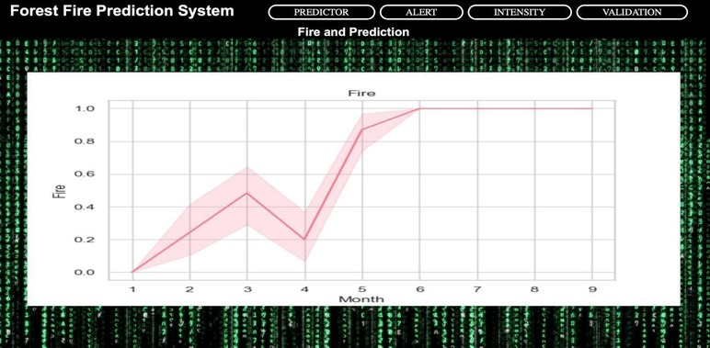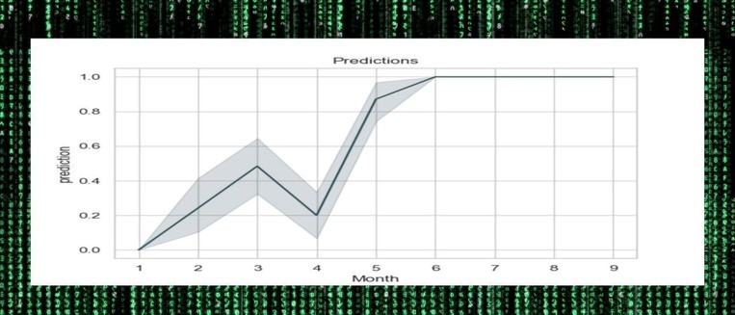

Fig 6.4 (a) and (b): Validation Predictions with Actual Fire Possibilities

Finally, an automated alert system sends the generated forest fire report via Email as

shown in Fig 6.5.

●

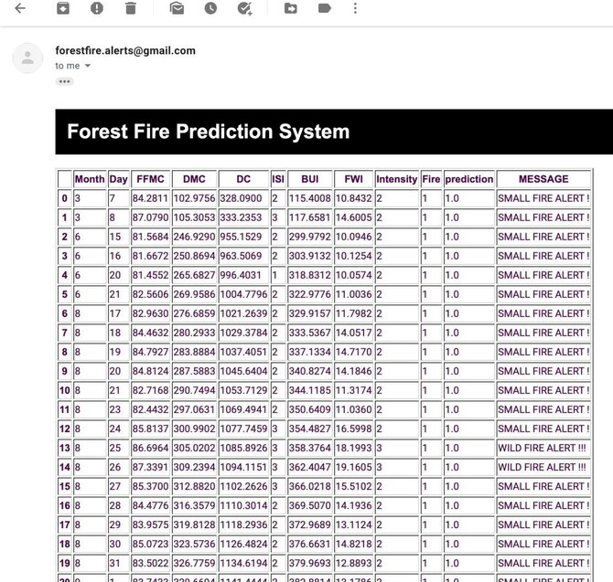

Fig 6.5: Forest Fire Prediction Report sent as Alert



CHAPTER 7

TESTING

Recall:

7.1

Performance of the model

The performance of the two algorithms, Linear SVM and Parallel SVM are tested on the basis

of four parameters which are Accuracy, Precision, Recall and Execution time.

Recall refers to the percentage of total relevant results correctly classified i.e., this is the case

when in reality, fire has actually happened and how often did our model get it right.

Recall = True Positive/ (True Positive + False Negative)

●

Accuracy:

Accuracy is the number of correctly predicted data points out of all the data points. More

formally, it gives us an idea about how well our model predicted the occurrence of forest fires.

Accuracy = (True Positive + True Negative)/ (True Positive + False Positive + True

Negative + False Negative)

●

Precision:

Precision means the percentage of your results which are relevant i.e. ratio of all correct positive

classifications to the total no. of positive classifications.

Precision = True Positive/ (True Positive + False Positive)

For our model, it tells us when the model predicted TRUE i.e., the forest fire will happen and

how often it was right.



●

Execution time:

The time taken by the model to make predictions is considered as the execution time for the

model. We use the timer () function to calculate the time taken to predict.

The

performance

of

the

system

was

tested

for

different

datasets

using

LSVM

and

PSVM.

It

was

observed

that

PSVM

was

more

efficient

and

had

better

accuracy

compared to LSVM. The results were stable for PSVM compared to LSVM. Therefore

we conclude that the predictions made by PSVM are more reliable to predict forest fires.

Linear SVM has lower accuracy when the dataset is too huge and becomes less reliable

while parallel SVM filters the most optimal support vectors and gives a more reliable

model to predict forest fires. The alerts generated are based on the Parallel SVM model.

Observation:

Code for PSVM Performance

***from***

***sklearn.metrics***

***import***

***classification_report, confusion_matrix***

Code for LSVM Performance

***from***

***sklearn.metrics***

***import***

***classification_report, confusion_matrix***

***print***

***(***

***lsvmrecall***

***)***

***print***

***(***

***end-start***

***)***

***print***

***(***

***end1-start***

***1)***

***print***

***(***

***lsvmaccuracy***

***)***

***print***

***(***

***lsvmprecision***

***)***

***print***

***(***

***metrics.recall_score(l, y_pred***

***))***

***print***

***(***

***metrics.precision_score(l, y_pred***

***))***

***lsvmaccuracy = metrics.accuracy_score(expected,predicted)***

***lsvmprecision=metrics.precision_score(expected, predicted)***

***lsvmrecall=metrics.recall_score(expected, predicted)***



7.2

Comparison between Linear SVM and Parallel SVM

Parameters

Accuracy

Recall

Precision

Execution time(in s)

Linear SVM

0.94

0.93

1.0

0.0006

Table 7.1: Comparison between Linear SVM and Parallel SVM

Parallel SVM

1.0

1.0

1.0

0.051



CHAPTER 8

CONCLUSION AND FUTURE SCOPE

8.1

Conclusion

Forest fires may happen because of many causes, accurate predictions are our target.

Using weather data and analysing the forest weather indices for training our model is

one of the best methods. Our work shows that the easiest way to predict forest fires is by

using Support Vector Machines. For small fires, which ultimately trigger bigger fires,

there are more reliable tests. But support for large data sets on Support vector machines

would have several support vectors to minimize accuracy. We need accurate and reliable

data.

It

is

critical.

Via

parallel

computation,

we

can

boost

the

support

vectors.

We

conclude that by modifying the algorithm and using parallel calculation, performance

and calculation time are improved. There is however, a higher memory requirement and

an

increase

in

computational

time.

For

this,

we

make

use

of

the

Apache

Spark

framework.

For implementing our model we have used the django framework for our user interface

and integrated the prediction algorithm as the django model. This prediction model makes use

of pyspark which is the Python API written in python to support Apache Spark. Apache Spark

is a distributed framework that can handle Big Data analysis.

Spark is basically a computational

engine that works with huge sets of data by processing them in parallel and batch systems.

Using these modules we have implemented parallel SVM that uses the weather data and uses

parallel computing to predict forest fires. This way we want to make our model more efficient

and reliable. We have an additional alerting system that can be used to alert a specific

department by just uploading the weather data of a particular station. This way we can help the

managing forest fires before it destroys the whole forest. This makes prevention easier by

predicting forest fires easily.



8.2

Future scope

Forest fires cause deforestation and land burning. Forest fires are considered socially and

economically unwelcome as they burn large amounts of land and may require some time

to recover it. Thus it is important to prevent forest fires. Our model is used to predict

forest fires. It has an accuracy of 0.99. Our model can be improved by making it live data

processing,

on

site

predictions,

making

it

sensor

based

etc.

In

the

future

we

hope

to

improve the speed and accuracy of the working model.



REFERENCES

[1]

Predicting forest fires using supervised and ensemble machine learning algorithms by R.

Rishickesh, A. Shahina, A. Nayeemulla Khan

[5]

A Data Mining Approach to Predict Forest Fires using Meteorological Data by Paulo

Cortez and An´ıbal Morais

[2]

Assessing the suitability of soft computing approaches for forest fire prediction by Samaher

Al_Janabi a, Ibrahim Al_Shourbaji b, Mahdi A. Salman a

[4]

Various approaches in Forest Fire Detection by Parul Mohindru, Vikshant Khanna, Rajdeep

Singh

[6]

Study on parallel SVM based on Mapreduce by Zhanquan Sun1 , Geoffrey Fox

[7]

Bisquert M., Caselles E., Sánchez J.M., Caselles V. “Application of artificial neural

networks and logistic regression to the prediction of forest fire danger in Galicia using MODIS

data”,July 2012 International Journal of Wildland Fire 21(8):1025-1029 DOI:

10.1071

/WF

11105

[8]

Satir, Onur, Suha Berberoglu, and Cenk Donmez. "Mapping regional forest fire probability

using artificial neural network models in a Mediterranean forest ecosystem." Geomatics,

Natural Hazards and Risk 7.5 (2016): 1645-1658.

[9]

K V Suresh Babu, Thesis on ”Developing Forest Fire Danger Index Using Geo-Spatial

Techniques”, IIT Hyderabad Date: 2019-03-09. Report no: IIIT/TH/2019/21.

[3]

Learning to predict forest fires with different data mining techniques by Daniela Stojanova,

Panče Panov, Andrej Kobler, Sašo Džeroski, Katerina Taškova



[14]

“Machine

Learning

with

Text

in

PySpark “,

[13]

“

Apply CSS class to Pandas DataFrame using to_html”,

https://stackoverflow.com/questions/50807744/apply-css-class-to-pandas-dataframe-

using-to- html/50939211

[16]

,

“Interpreting

Fwi) System“

(

The

Canadian

Forest

Fire

Weather

Index

http://www.dnr.state.mi.us/WWW/FMD/WEATHER/Reference/FWI_Background.pdf

“Identifying the Threshold of Dominant Controls on Fire Spread in a Boreal Forest

[17]

Landscape of Northeast China”,

https://journals.plos.org/plosone/article?id=10.1371/journal.pone.0055618

[15]

“django spark - event sourcing and handling” ,

https://pypi.org/project/django-spark/

[10]

Zhu,

Kaihua,

Hao

Wang,

Hongjie

Bai,

Jian

Li,

Zhihuan

Qiu,

Hang

Cui,

and

Edward Y. Chang. "Parallelizing support vector machines on distributed computers." In

Advances in Neural Information Processing Systems, pp. 257-264. 2008.

Guo, W., Alham, N. K., Liu, Y., Li, M., & Qi, M. (2016). A resource aware MapReduce

[11]

based parallel SVM for large scale image classifications. Neural Processing Letters, 44(1),

161- 184.

[12]

“

Pandas Dataframe: Plot Examples with Matplotlib and Pyplot” ,

https://queirozf.com/entries/pandas-dataframe-plot-examples-with-matplotlib-

pyplot

https://datascience- enthusiast.com/Python/PySpark_ML_with_Text_part1.html



[18]

“

Classification and regression” ,

https://spark.apache.org/docs/2.2.0/ml-classification-

regression.html#linear-support-vector-machine

[19]

“How to extract weather data from Google in Python” ,

ht

t

ps://www.t

hep

yt

ho

nco

de.

co

m/art

ic

le/e

xt

r

act

-

weat

her

-

dat

a-

python

[20]

“Case studies in fire safety” ,

https://www.sciencedirect.com/science/article/pii/S2214398X16300

127

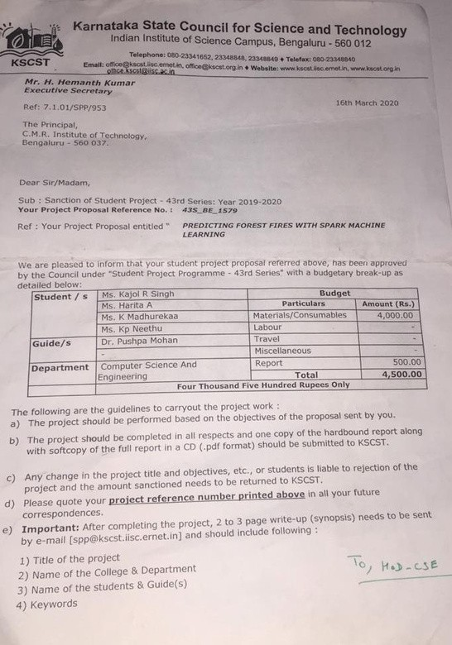

APPENDIX- A

Our Project was selected for KARNATAKA STATE COUNCIL FOR SCIENCE AND

TECHNOLOGY.

